Animal Tracking Collar

Field Researcher User Manual

**Prepared by:**

Ben Lawson

Ben Shewan

Collin Halamka

Collin Maker

Garrett Harris

**Submitted to:**

Dr. Paul Keenlance

Dr. Jeffrey Ward

Dr. Bruce Dunne

EGR 485/486 Senior Project

Spring/Summer Term 2019

**June 2019**

**[This page intentionally left blank]**

**Table of Contents**

**1. Manual and Device Overview** **4**

Mechanical Hardware 4

Device Software and Programming 4

**2. Mechanical Assembly and Disassembly** **5**

2.1 Medium Collar Basic Assembly and Disassembly 5

2.1.1 Accessing enclosure for battery replacement 5

2.1.1.1 To access the enclosure and replace the battery will require a 2mm hex wrench and needle nosed pliers. 5

2.2 Adjusting the Collar Strap 6

2.3 Hall Effect Sensor Clip 7

**3. Standard Operation, Troubleshooting, and Debugging** **9**

3.1 Programming Collar Schedule Via the Graphical User Interface 9

3.1.1 Launching the Program 9

3.1.2 Entering the Programming Page 9

3.1.3 Connect to the Collar 10

3.1.4 Set Up The Program 12

3.1.5 Program The Collar 14

3.1.6 Power Calculation 14

3.2 Downloading GPS Data Via the Graphical User Interface 15

3.2.1 Wireless Downloading - Setup 15

3.2.2 Wireless Downloading - Procedure 16

3.2.3 Wired Downloading - Procedure 16

3.2.3 Clearing Device Storage 17

# 1. Manual and Device Overview

This manual overviews the basic assembly, programming of parameters, and operation of the 2019 GPS Wildlife Tracking Collar. The device is constructed of a strap and enclosure, sealed by a gasket. This manual detailed how to assemble these components. A printed circuit board (PCB) is housed in the enclosure where it will remain waterproof and protected from the elements while operating to the capacity programmed by the researcher. The circuit board is powered by a Tadiran AA battery that is placed atop the PCB. Programming headers are locatable on the PCB where the user can connect and set acquisition parameters. This manual also describes how to connect to the device, launch the user interface program, program the collar, and collect/download the recorded data.

## Mechanical Hardware

The mechanical hardware section of the manual details the general assembly and adjustment of the device. Enclosure assembly is explained in detail for battery extraction and lid sealing, as well as adjusting the collar strap to the desired size. Finally, insertion and extraction of the hall effect magnetic sensor is described to turn the device to the “OFF” and “ON” states while a battery is present.

## Device Software and Programming

The software and programming section of the manual details the steps taken in order to connect to the device, launch the user interface program, navigate the user interface program, program the collar to the desired parameters, enter the power calculation section of program, obtaining collected data (wired and wirelessly), and clearing the devices stored data in memory for future field deployments.

# 2. Mechanical Assembly and Disassembly

## 2.1 Medium Collar Basic Assembly and Disassembly

## 2.1.1 Accessing enclosure for battery replacement

## 2.1.1.1 To access the enclosure and replace the battery will require a 2mm hex wrench and needle nosed pliers.

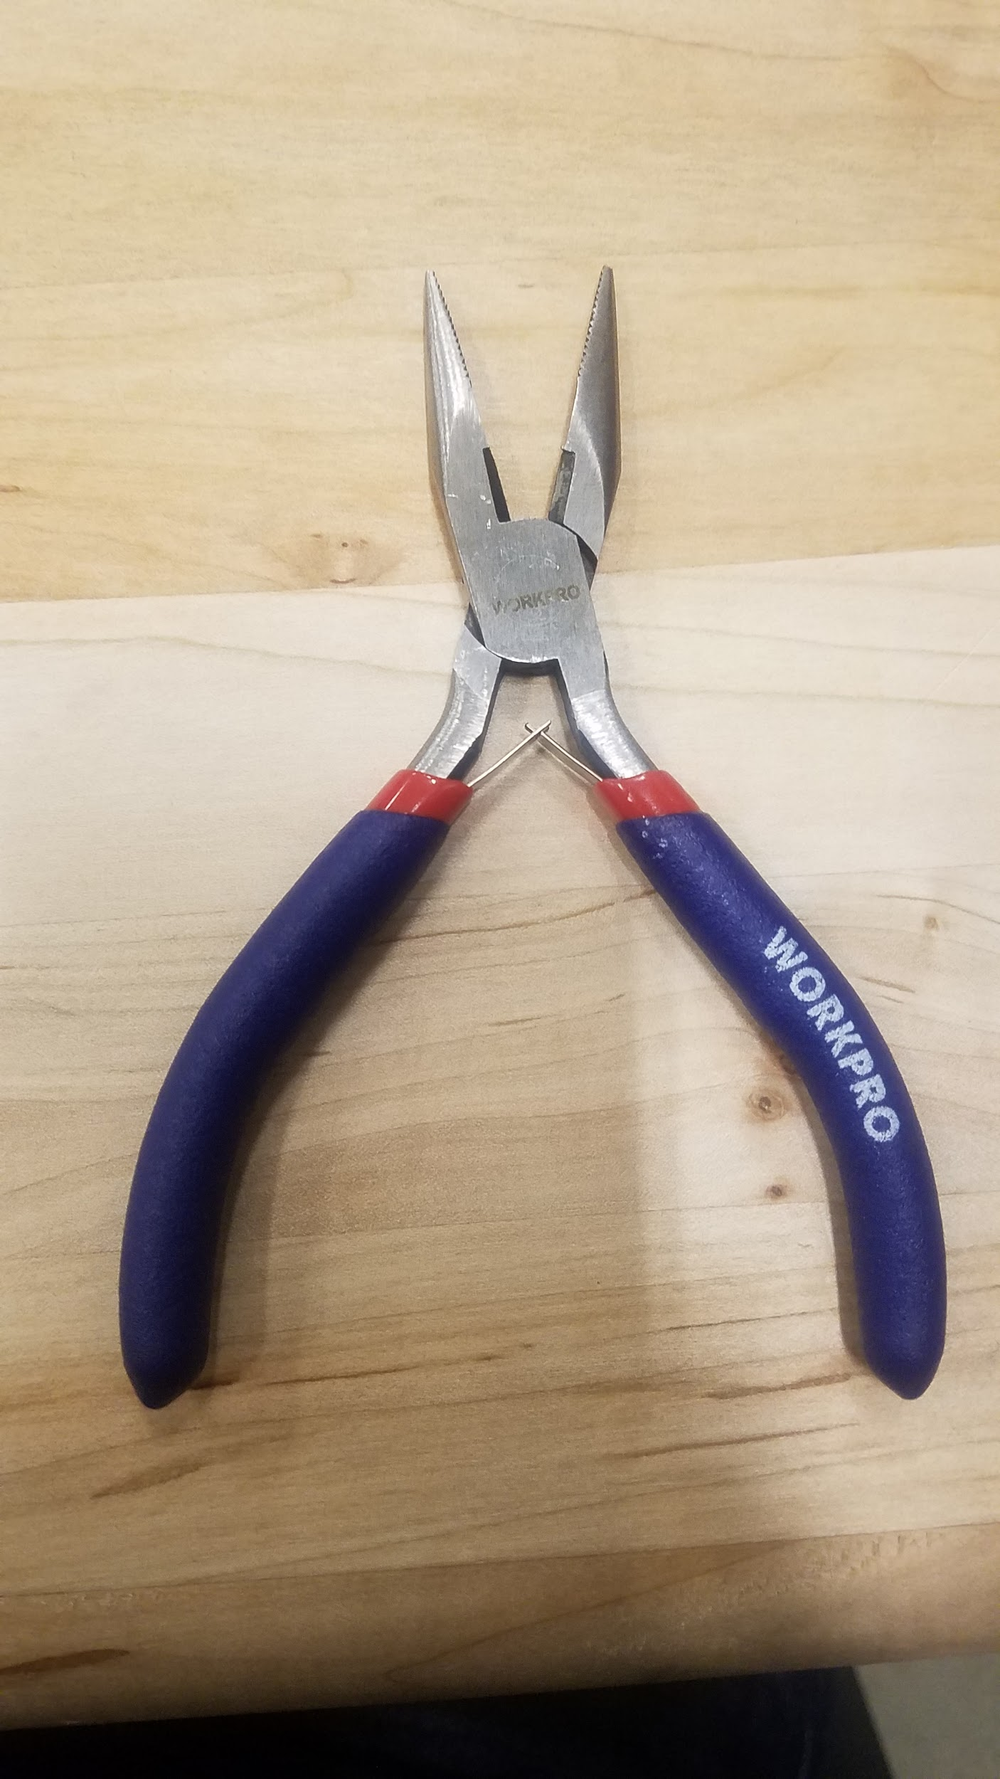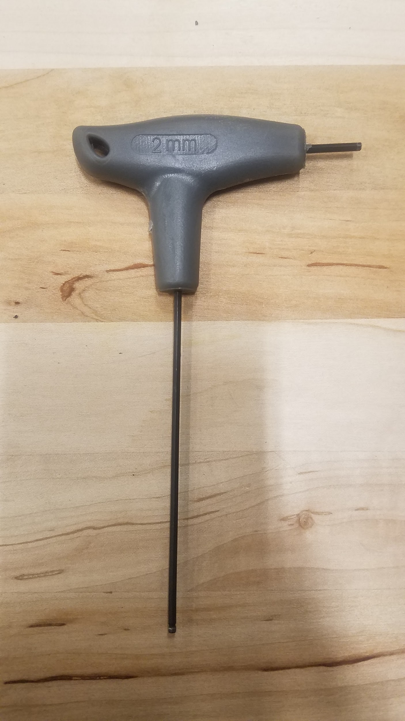

**Figure 1.** Required tools shown above, pliers and 2mm hex driver.

**2.1.1.2** Remove the four nylon locking nuts, shown in figure x, below, by holding the nut stationary while backing the M3x20 fastener out of each corner. It is not necessary to remove the 3mm fastener completely, only to free the nut. Do not lose the nut (spares are provided), as it will be required for re-assembly.

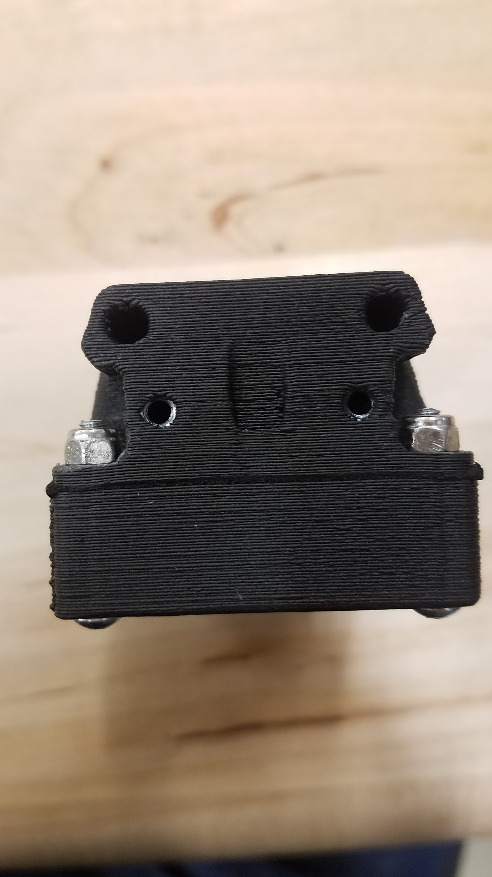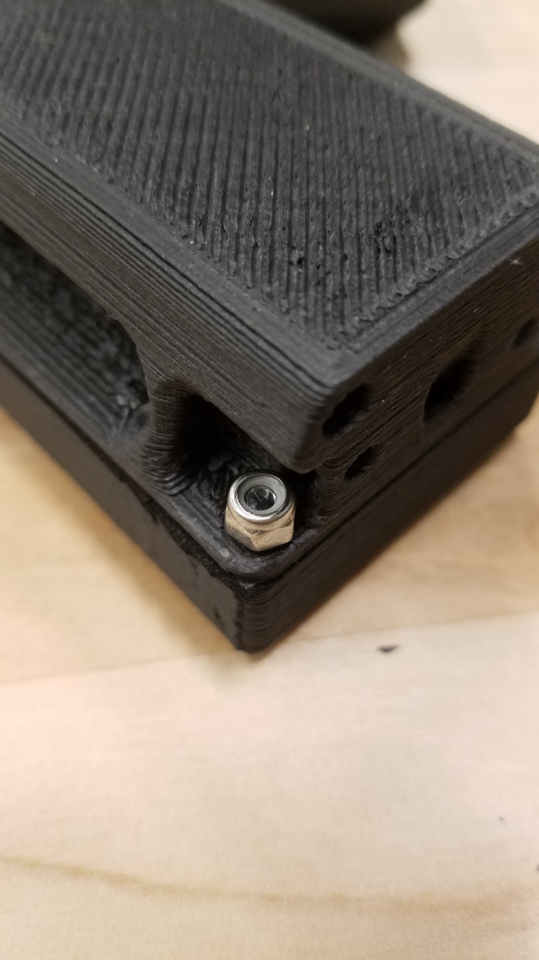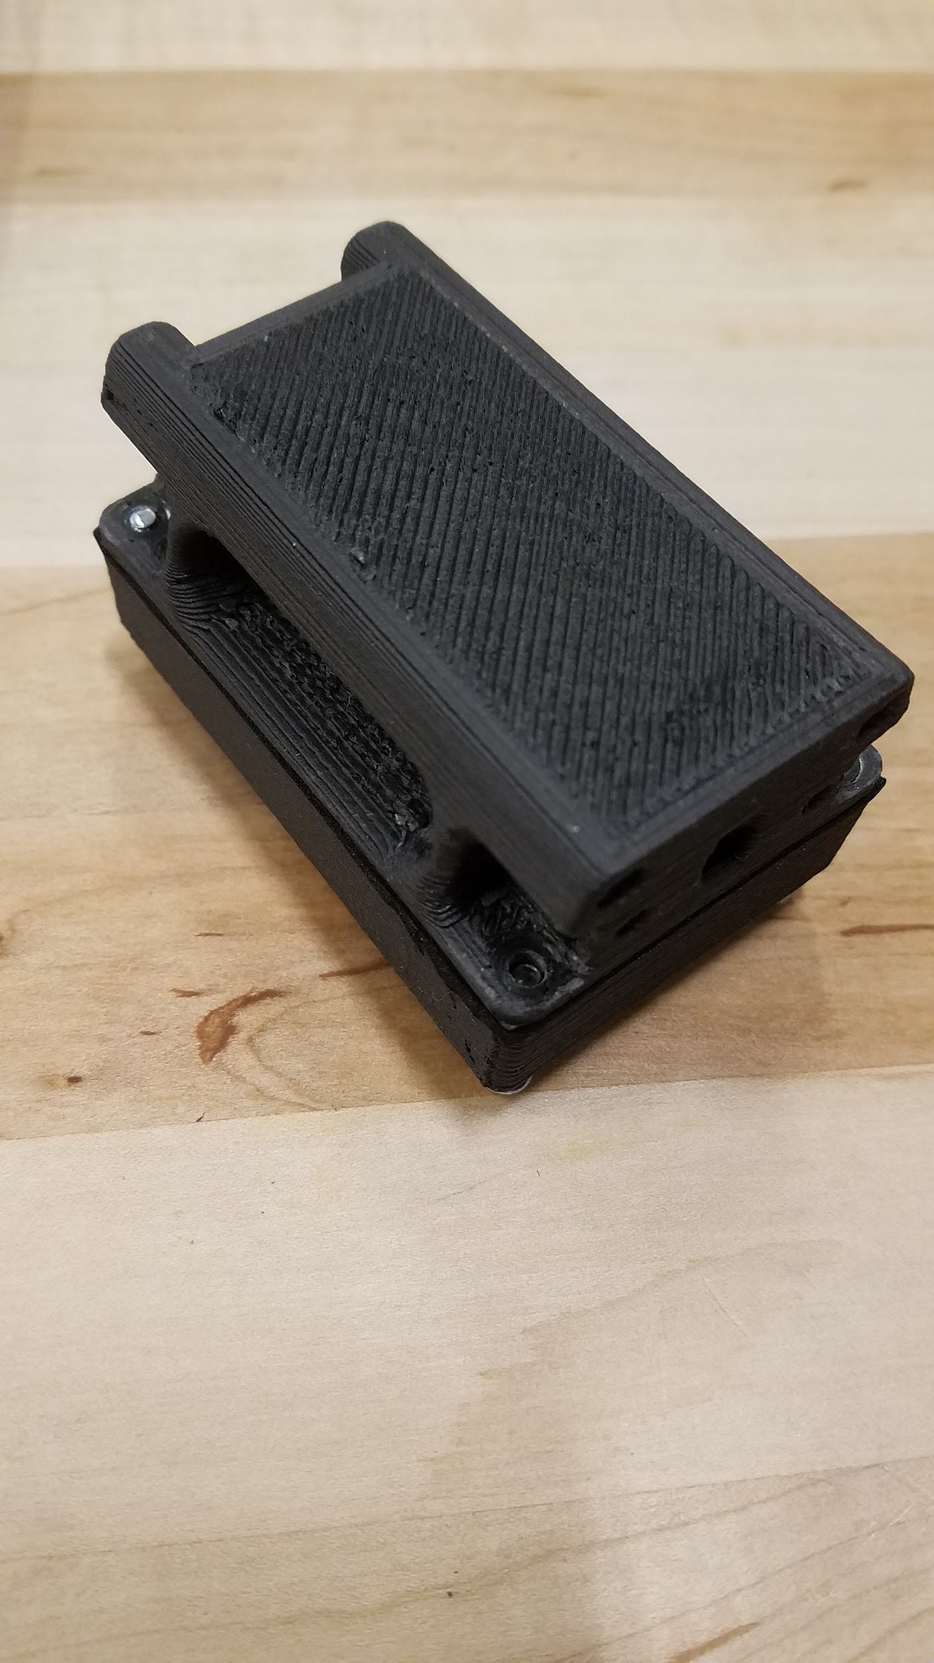

**Figure 2.**  From left: Nuts in place, nut loosened, nut removed.

**2.1.1.3** After removing the 4 locking nuts the lid can swing open. Be careful to not over stress the wire antennas . Access to the battery has now been obtained.

## 2.2 Adjusting the Collar Strap

**2.2.1** The assembled collar will have a stud plate and will be set to the largest size. To open the collar strap and adjust the size, a pair of pliers or an 11/32 socket driver, will be required.

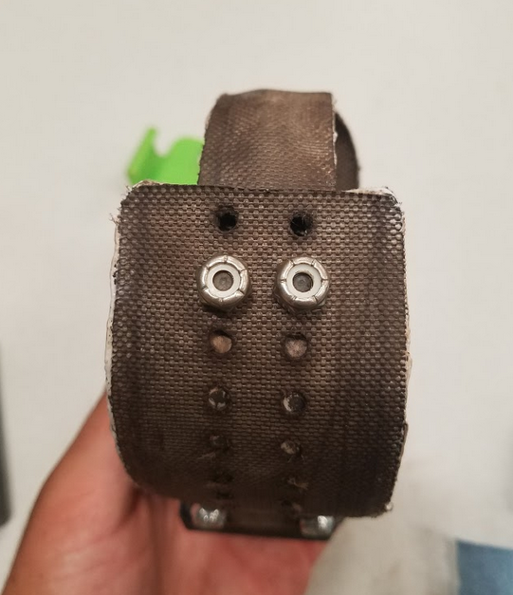

**Figure 3. Stud plate inserted into sleeve of collar (lightly fastened)**

**2.2.2** Hold the strap and stud plate in place and loosen the 8-32 nuts. When the nuts are removed squeeze the shorter strap on either side, as shown below, and remove the end of the 200mm strap end. Then place the collar around the neck of the chosen specimen. Feed the end of the collar back into the 110mm strap, stud plate legs facing out. Select an appropriate size and force the legs through the holes to the outside.

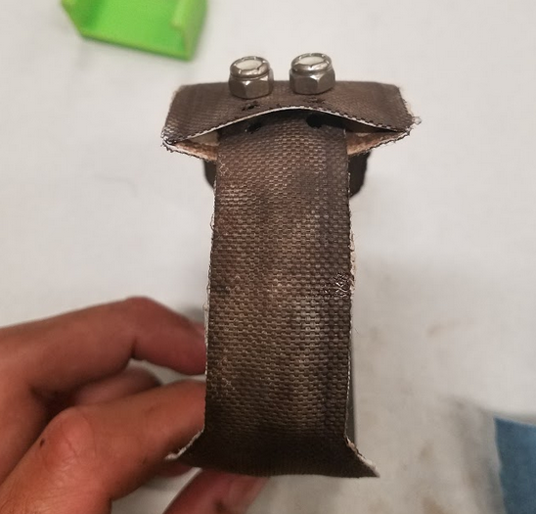

**Figure 4: Inserted and secured stud plate & strap, slightly bowed strap sleeve**

**2.2.3** Re-attach the 8-32 nuts to the stud plates and tighten. The collar is now attached to the specimen chosen.

## 2.3 Hall Effect Sensor Clip

**2.3.1** The assembled collar enclosure will accept the hall effect sensor clip. Be sure that the head of the clip faces the antenna side of the enclosure. Failure to do so will allow the collar to remain on and drain the battery.

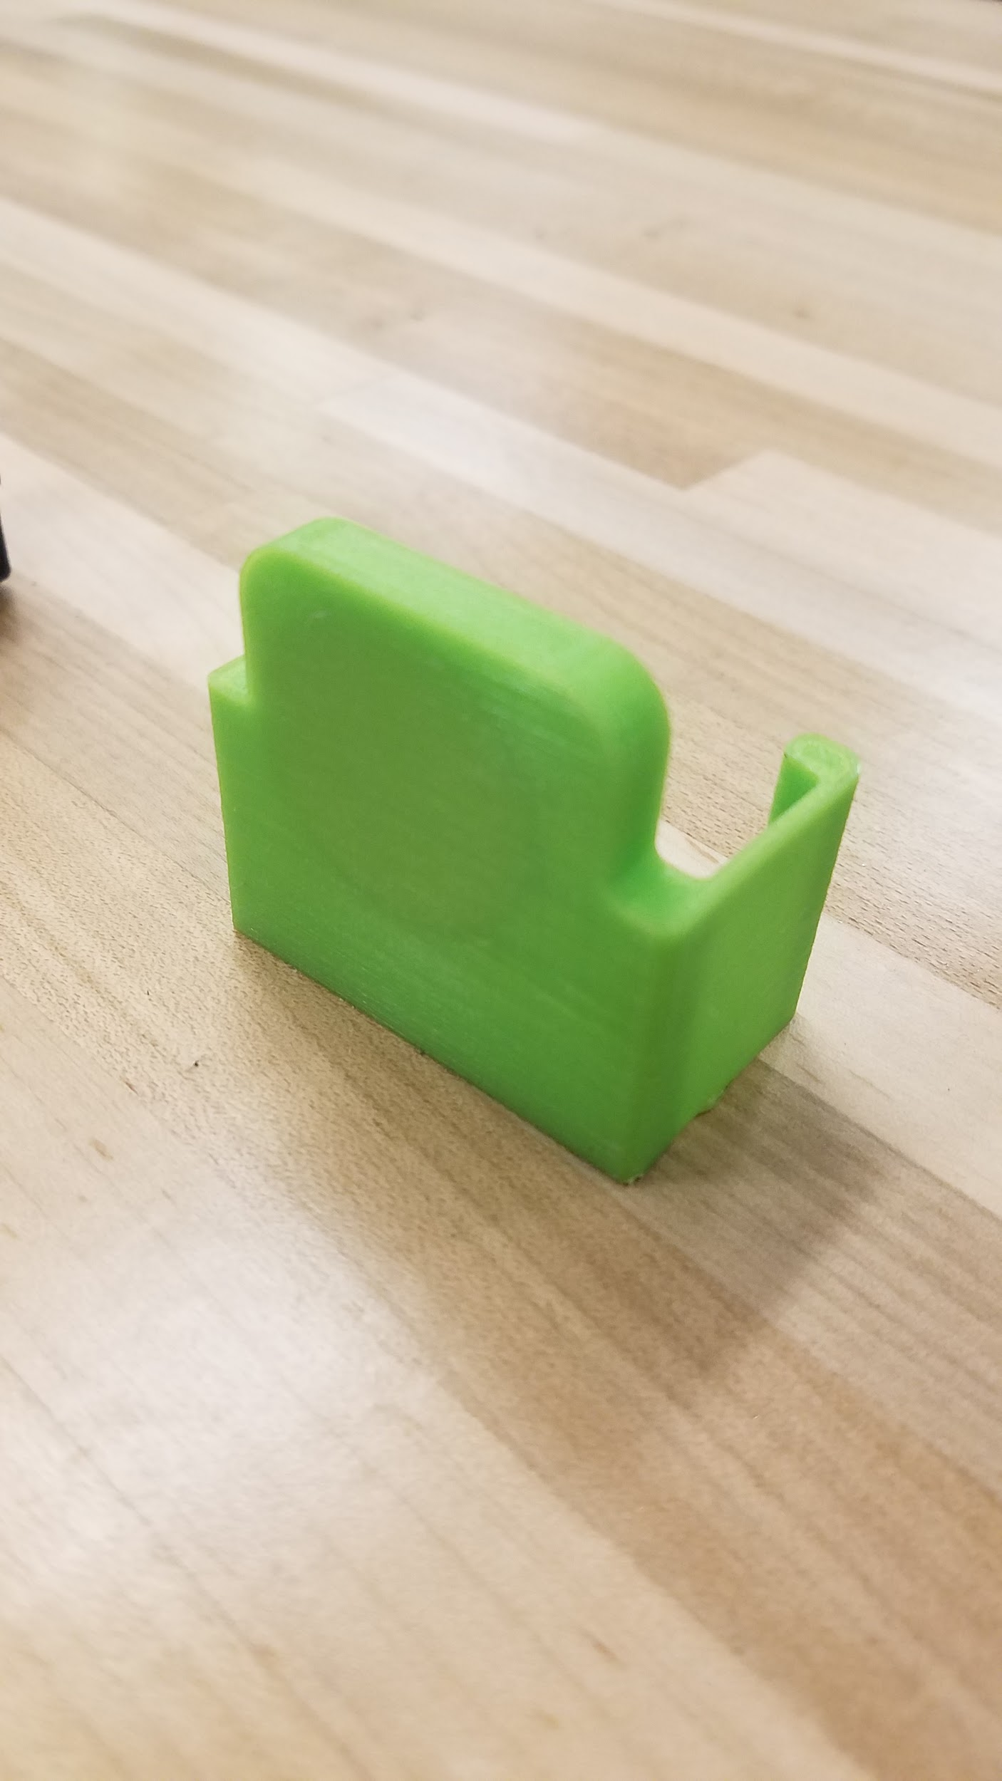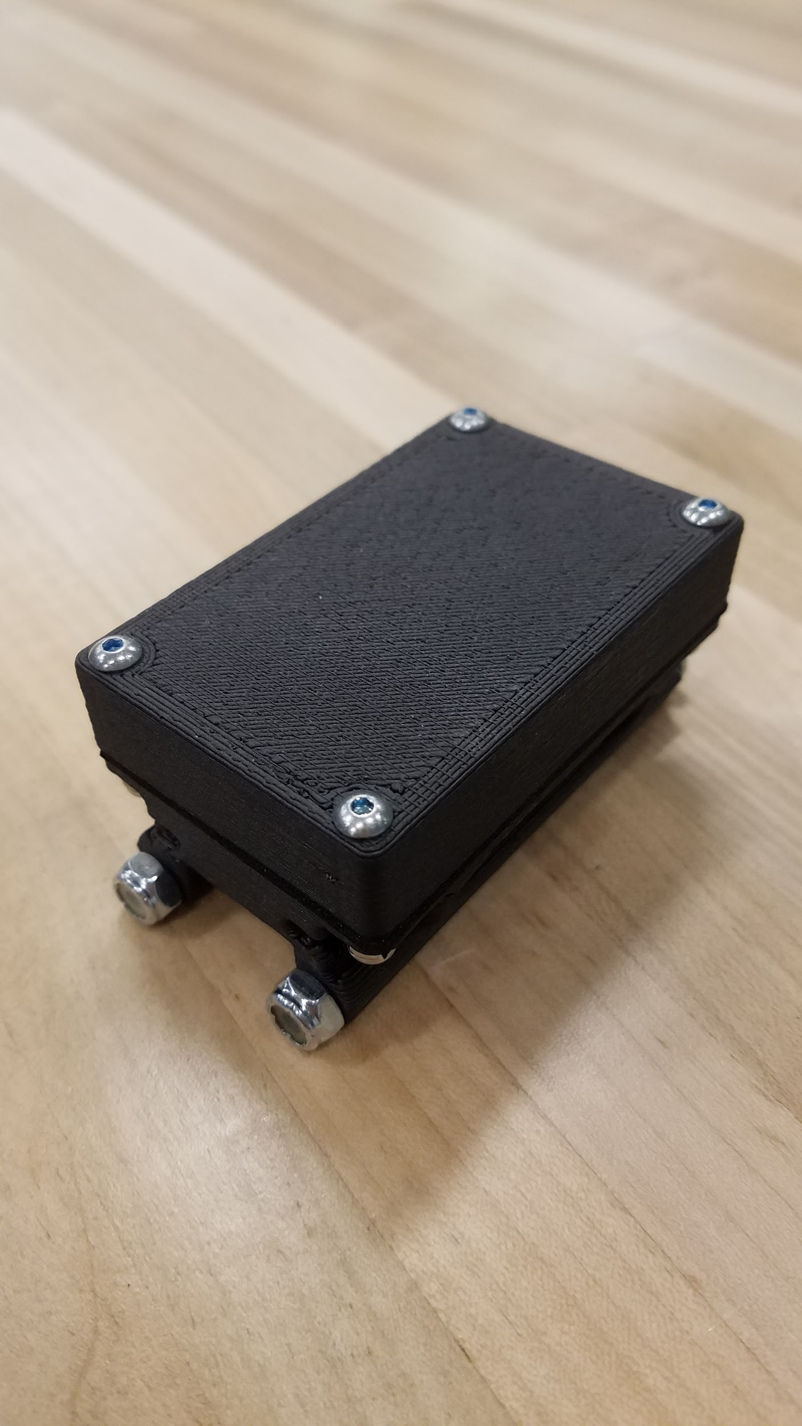

**Figure 4.1 and 4.2.** Right: Battery Clip, Left: Enclosure Assembly

**2.3.2** Take the hall effect sensor clip and stretch it over the sides of the enclosure assembly as shown. Be sure that the clip is facing the antenna end of the enclosure. Then Push down until you hear it clip into place.

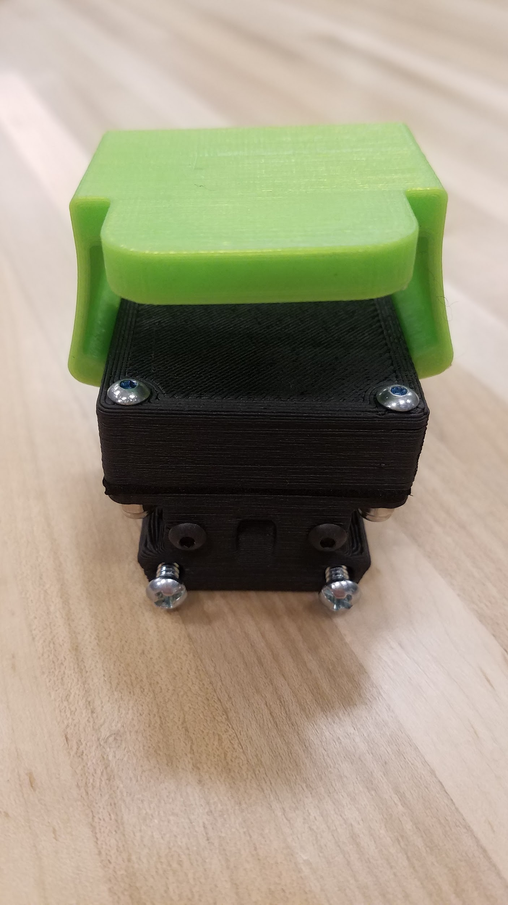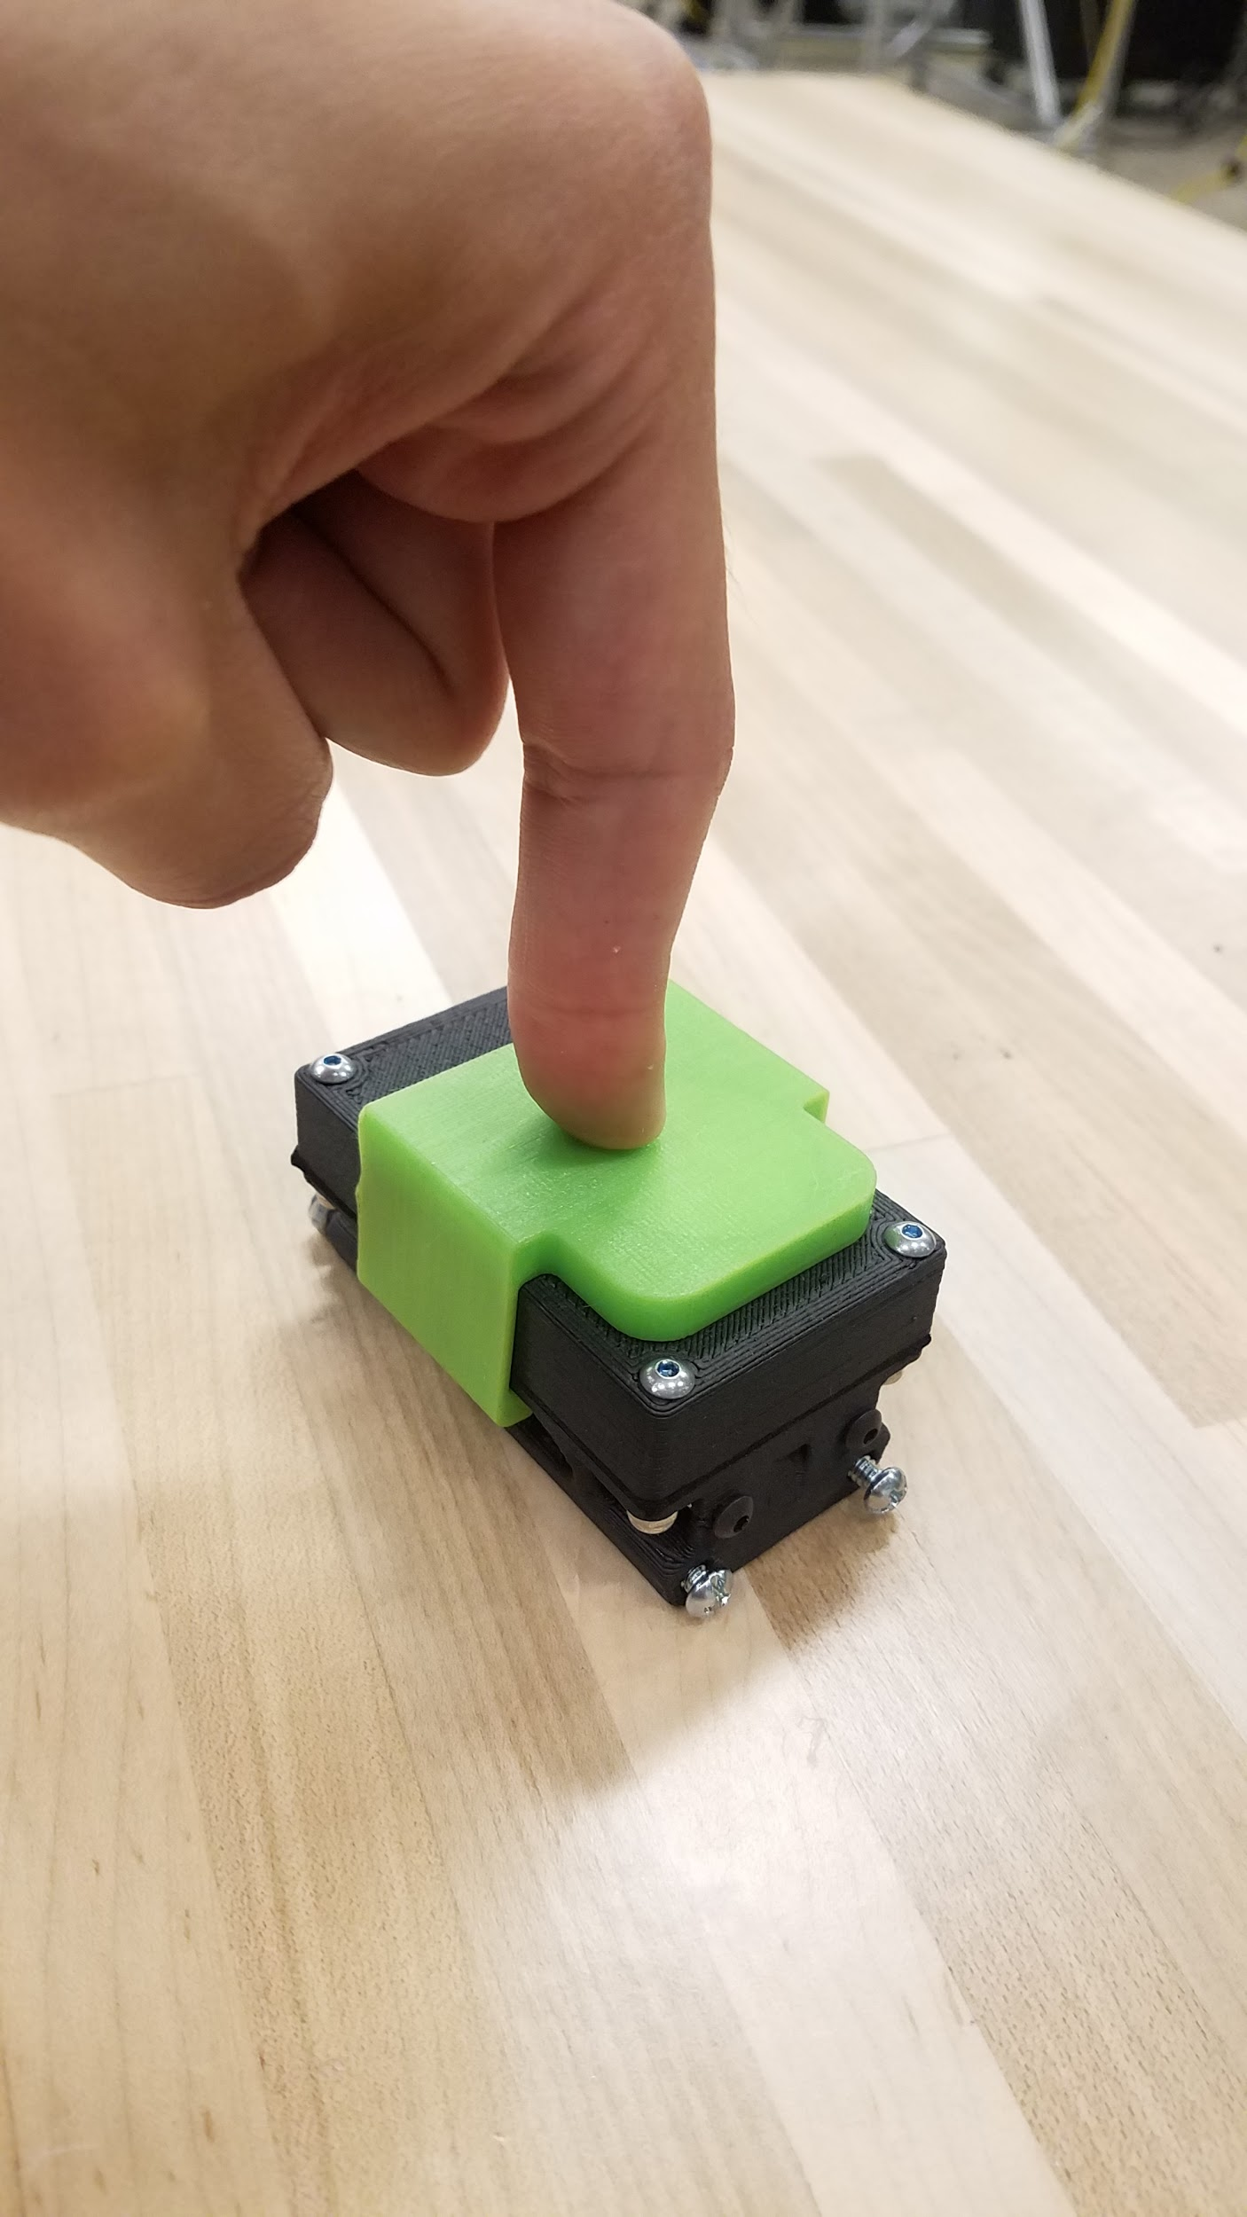

**Figure 6 and 7.** Right: Clip placed on top of enclosure, Left: Clip snapped into place

**2.3.3** After the clip is fixed in place, force it towards the end until the clip touches the heads of the fasteners, as shown.

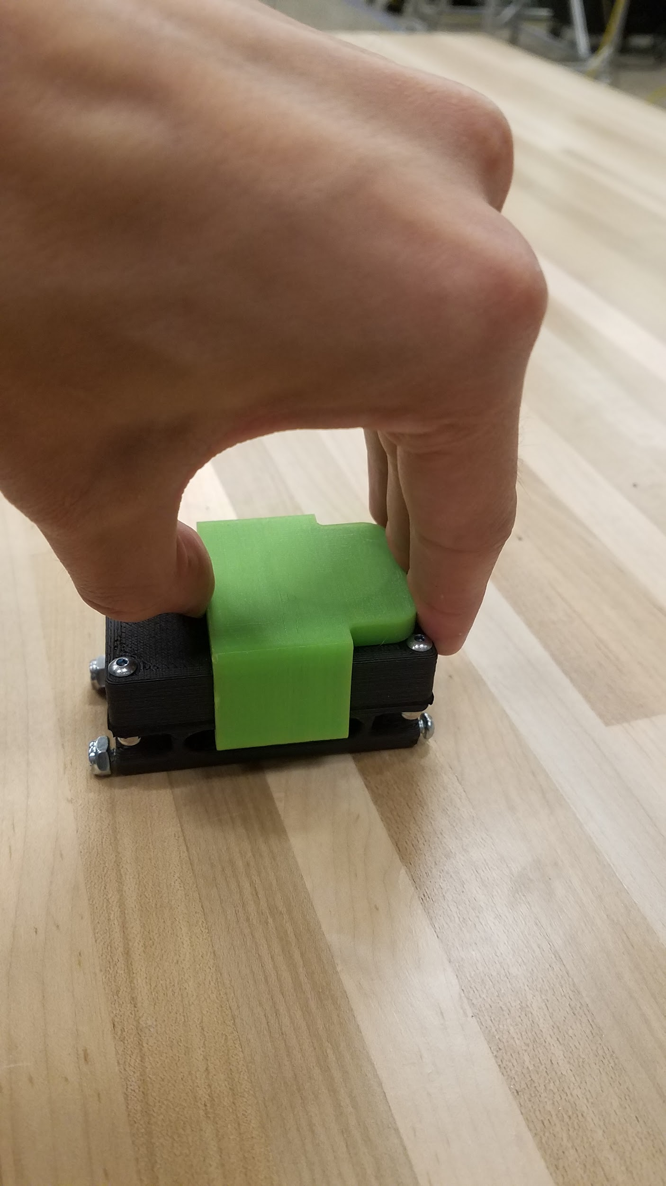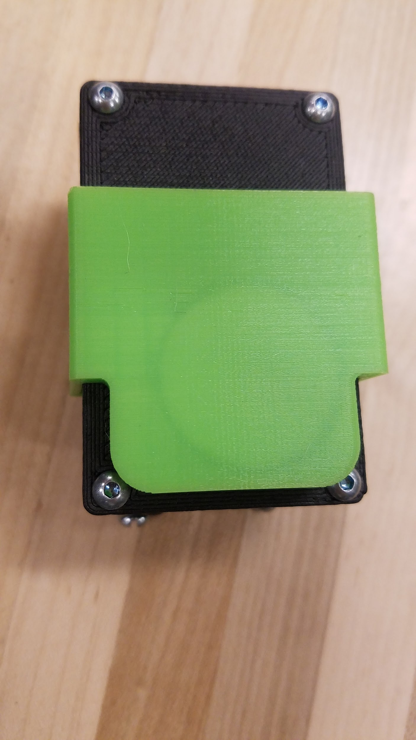

**Figure 8 and 9.** Right: Clip moving into place, Left: Clip in final position

**2.3.4** The hall effect switch is now activated and the collar is in sleep mode.

# 3. Standard Operation, Troubleshooting, and Debugging

## 3.1 Programming Collar Schedule Via the Graphical User Interface

## 3.1.1 Launching the Program

To start the program, the user must simply double click the “CollarProgram.exe” file in the folder associated with the program and its various files. Or, double click the associated desktop shortcut.

## 3.1.2 Entering the Programming Page

At the start of the program, the software will take the user to the home page. The user should navigate to the “Direct Collar Connection” page in order to communicate with the collar directly over USB port.

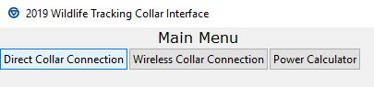

**Figure X.**  Program Main Menu

This button will navigate the user to the following page.

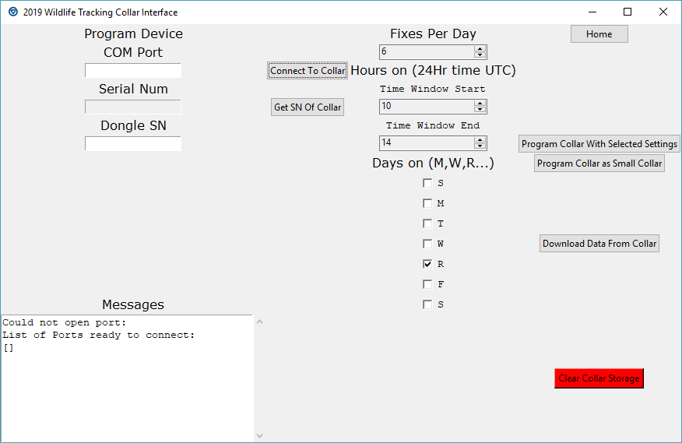

**Figure 10.**  Wired Connection Page

Now that the user is on the Wired Connection page, they must make a connection to the collar over the USB dongle.

## 3.1.3 Connect to the Collar

The collar should be connected to the programming board with the proper ribbon cable attachment. Then, the programming board should be attached to the computer via the USB dongle. At this time, the onboard LED should now begin flashing, indicating it is getting power from the USB dongle.

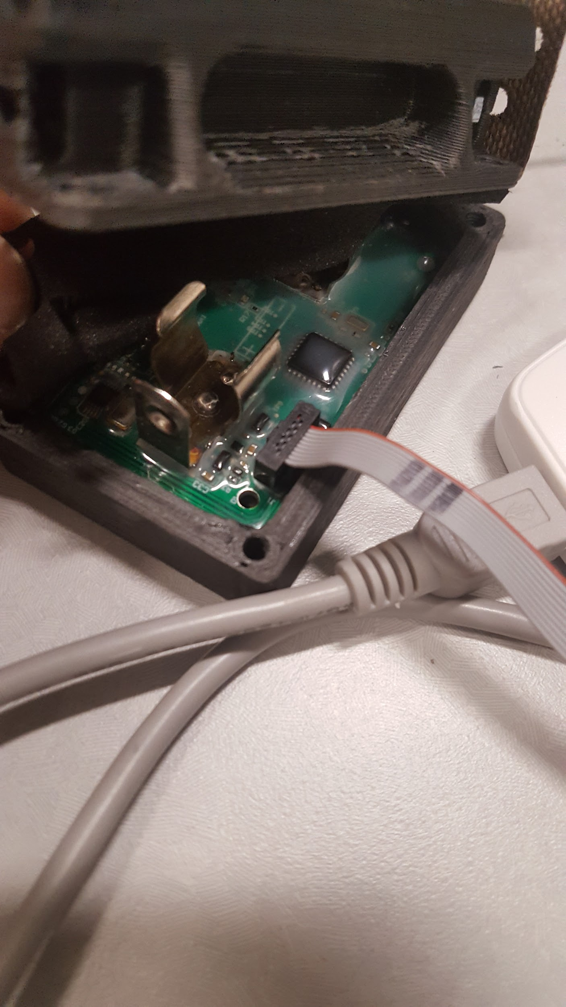

**Figure 11.**  Wired Connection

Now, the researcher should discover which COMPORT the computer has assigned the dongle. If the COMPORT is already known by the researcher, skip the next step.

To discover the COMPORT, there are two options.

1. If the user leaves the COMPORT field blank and makes a connection attempt, the message box will list available COMPORTs. Any listed COMPORT may be attempted (there is likely to be only one if the only device connected to the computer is the collar dongle).

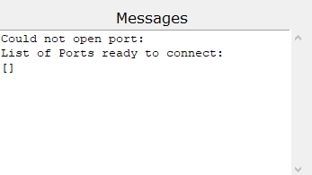

**Figure 12.**  Comport List Via Program

1. Otherwise, the researcher can discover available ports directly. To do this, type “Device Manager” in the windows search bar. Then, select the dropdown that says “COM Ports” and record the number associated with the virtual USB serial port.

**Figure 13.**  Device Manager Example

After the number is discovered, put this number in the COM Port data entry slot of the GUI and press connect.

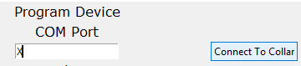

**Figure 14.**  Attempting Collar Handshake

The messages box should have a message that reads “Handshake completed successfully” and the blue onboard LED should stop flashing and remain on. If it does not, try removing and reseating the battery and unplugging and reseating the cable that connects the programming board to the collar.

## 3.1.4 Set Up The Program

There are 5 important data fields for the medium collar and 1 for the small collar. The medium collar requires:

1. GPS fixes per day
2. Start time VHF and XBee download window in UTC
3. End time VHF and XBee download windows in UTC
4. The days of the week this window applies to in UTC
5. The Serial Number of the Xbee Receiver dongle the researcher is using, (this number can be retrieved in the Download Page of the program when the dongle is attached)

These fields are depicted below. The small collars only require configuration of field 1 (GPS Fixes).



**Figure 15.**  Programming Option Fields

To retrieve the dongle serial number, navigate to the “Wireless Collar Connection” page by selecting “Home” to return to the home screen then the “Wireless Collar Connection button”. This will lead the user to the screen depicted below.

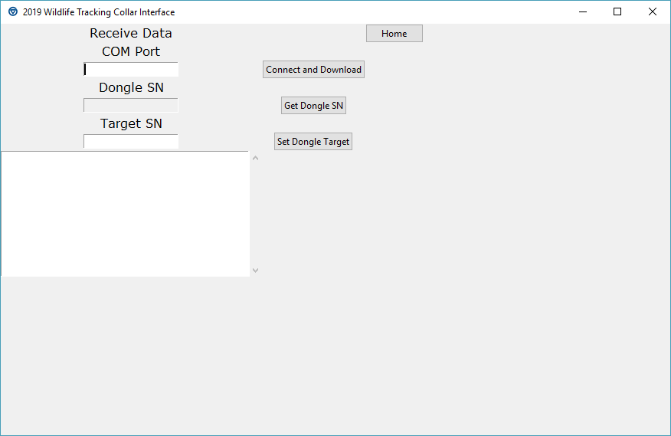

**Figure 16.** Wireless Connection Screen

In this screen use the same steps as 3.1.3 to get the COMPORT for the Wireless Dongle, then press “Get Dongle SN”. This button will get the SN of the dongle which can be copied from the data field. Then, return to the Wired Connection Screen and continue.

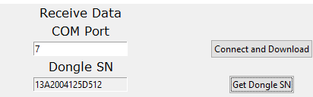

**Figure 17.**  Using Wireless Page to Retrieve Dongle Serial Number

After entering all of the appropriate data in the user interface, and a connection has been made to the collar, the Program Collar button should be pressed and the message box should be monitored for completion. A file with the program information will be created and stored in the same location as the program launch file.

The small collar follows a similar procedure except only the fixes per day category matters in this instance. Instead of the “Program Collar” button, the “Program Collar as Small Collar” should be selected.



**Figure 18.**  Programming Operation Buttons

## 3.1.5 Program The Collar

There is a collar program button for both the small and medium sized collars. After the program information is set up and a connection is established, the respective collar can be programmed with these buttons. Wait until the program is finished programming the collar and the message box prompts the user of this status. Information about what is being programmed to the collar will be saved in a text file in the program location with the filename being printed to the message screen. The medium collars should be saved with the filename of their Xbee serial number and the small collars, lacking a serial number, will be saved with the current time and date. These files are for reference only and can be moved or saved elsewhere at user's discretion.

If the programming process fails, first ensure that the collar is connected properly with a handshake confirmed message. Then, ensure that the proper program button is being pressed. Finally, press the program button again as timing errors occasionally occur.

## 3.1.6 Power Calculation

In order to intelligently program the collar, power considerations should be made. Therefore, included in the GUI is a link to a spreadsheet that will calculate an estimated battery life of the device under certain setting conditions. To reach this spreadsheet press the Power Calculator button on the home page.

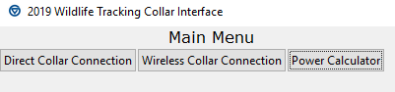

**Figure 19.**  Power Calculation Launcher

## 3.2 Downloading GPS Data Via the Graphical User Interface

## 3.2.1 Wireless Downloading - Setup

In order to connect to the collar in the field,the collar must be of the medium collar variety and the dongle must be configured to talk to the collar and vice versa, so ensure that the dongle in use is the one that the collar was configured to communicate with. Next, open the “Wireless Collar Connection” window of the GUI.

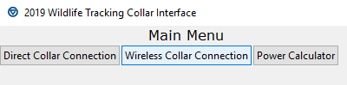

**Figure 20.**  Entering the Wireless Collar Connection Screen

Then, enter the serial number of the collar that the user wishes to download the data from into the Target SN field and then select Set Dongle Target. This serial number is saved in the configuration report created at time of programming.



**Figure 21.**  Setting Dongle Target Collar

If this does not work, ensure that the proper COM Port has been entered in the COM Port field. The COM Port can be found with the same procedure as described in the programming section of the manual. After the target serial number is confirmed, the dongle is ready to receive from the collar.

## 3.2.2 Wireless Downloading - Procedure

In order for the data to be downloaded from the collar, the Xbee on the collar will have to be operating in its XBee/VHF time window set in the programming phase. This window will set the XBee to be active for 20 seconds at the beginning of every minute as a power saving measure. Therefore, wait until the beginning of a minute and then press the “Connect and Download” which will attempt to establish contact and download the data from the collar.

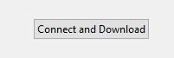

**Figure 22.**  Connect and Download from Collar

The program will notify the user if a connection was established via the message window and begin the download immediately. The file will be saved with the serial number of the collar it was downloaded from, followed by the time and date as the file name. Ensure that the file contains proper data before leaving the area as wireless transmission errors can occur. If not, attempt another connection in the next minute.

This will provide a CSV file formatted the same way as the example excel file found in the program folder. This file provides information on how to reformat the CSV after downloading as well.

## 3.2.3 Wired Downloading - Procedure

While only the medium collar is set up for wireless data retrieval, both collar sizes can have their data be downloaded via the Programming Page of the program after a proper connection has been established. Simply connect the device in the same manner as used when programming for deployment, then press the download data button. This will prompt the device to retrieve the stored fixes and save them to the computer in the same format as wirelessly.

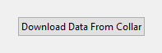

**Figure 23.**  Download Via Direct Connection

## 3.2.3 Clearing Device Storage

While the device holds more than enough storage space for a single deployment, depending on fix amount settings, it may not have enough free storage for multiple deployments. It is therefore best practice to clear the storage at time of programming. This process is only done when pressing the red colored “Clear Collar Storage” button. It is recommended that this button is only pushed after data has been downloaded as all data will be effectively lost after clearing.

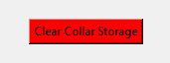

**Figure 24.**  Clear Data from Collar